**Hemichordates: the acorn worm.**

Hemichordates share some characteristics with chordates. There are **branchial openings**, or "gill slits," that open into the pharynx; there is a rudimentary structure in the collar region, the **stomochord**, that is similar to a **notochord**; and there is a dorsal nerve cord, in addition to a smaller ventral nerve cord.

Acorn worms are the most common hemichordate. They are slow burrowers and may deed on deposit almost like an earth worm or collect suspended particles.

**Exercise one: External anatomy.** Obtain a specimen that appears active.

**Photograph your animal and in your photograph identify, proboscis, collar and trunk.** Can you identify the pharyngeal gill slits or pores as they are dubbed in the diagram below? How far do they extend down the length of the animal?

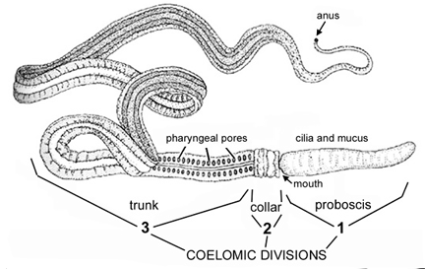

**Exercise two: Feeding**. Describe and try to film proboscis extension. Add some fish flakes to media. Does the worm try to feed? If not, it may be a suspension feeder and you may need to add some phyto or zoo plankton. In either case , if the worm starts feeding try to observe how the proboscis is used to move food to the mouth. **Obtain a short film of proboscis extension**. How many times original or resting length can the worm extend its proboscis? Use high power and try to see if you can see the cilia on the proboscis that directs the movement of food toward the mouth.

**Exercise three**: **Describe movement in the acorn worm**. Is movement more coordinated in the front of the animal where the stomochord is present?

Before you return your specimen, add some course sand to your dish. Does the animal attempt to burrow? Record any observations in your journal.

**Invertebrate Chordates**

**Cephalochordata**

With about twenty-five species inhabiting shallow tropical and temperate oceans, the Cephalochordata are a very small branch of the animal kingdom. Known as lancelets or as amphioxus (from the Greek for "both [ends] pointed," in reference to their shape), cephalochordates are small, eel-like, unprepossessing animals that spend much of their time buried in sand. However, because of their remarkable morphology, they have proved crucial in understanding the morphology and evolution of chordates in general -- including vertebrates.

We have living specimens of *Amphioxus.*

Obtain a live specimen of Amphioxus. Be very careful, these animals can use that notochord and powerful tail to flip several feet in the air. The evolutionary advantages of this arrangement will be obvious to you if you leave the dishes containing these animals unguarded. So please keep covers on this dish and only remove when filming.

**4. Try to feed your specimen. Can you identify how the material enters the body? Film feeding if possible.**

**5. Photograph your specimen.**

**Identify as many of the labeled structures as possible on diagrams one and two. Label gill slits, oral cirri and notochord.**

The dorsal nerve cord is supported by a muscularized rod, or notochord. The pharynx is perforated by over 100 pharyngeal slits or "gill slits", which are used to strain food particles out of the water. The musculature of the body is divided up into V-shaped blocks, or myomeres, and there is a post-anal tail. All of these features are shared with vertebrates. On the other hand, cephalochordates lack features found in most or all true vertebrates: the brain is very small and poorly developed, sense organs are also poorly developed, and there are no true vertebrae.

Internal anatomy of *Amphixious*



Water is taken in through the mouth, drawn in by the beating of cilia located on the wheel organ, a set of ridges lying inside the mouth. The water is first filtered by the oral cirri, slender projections that surround the opening of the mouth, clearly visible on the photograph at the top of the page. It then passes through the gill slits. These gill slits are enclosed by folds of the body wall, the metapleural folds, to form a body cavity known as the atrium. Food particles in the water are trapped by mucus, while water passes through the slits and out of the atrium through the atriopore, located towards the posterior end. The rest of the digestive system is fairly simple: a pouch or hepatic caecum secretes digestive enzymes, and actual digestion takes place in a specialized part of the intestine known as the iliocolonic ring. Cephalochordates also have a well-developed circulatory system and a simple excretory system composed of paired nephridia. The sexes are separate, and both males and females have multiple paired gonads. Eggs are fertilized externally, and develop into free-swimming, fishlike larvae.

Stained slide showing feeding mechanism of amphioxus.



1. Dorsal fin and fin ray 2. Dorsal nerve cord 3. Notochord 4. Rostrum 5. Vestibule 6. Wheel organ 7. Oral cirri 8. Velum

9. Gillbar

Notice that the anterior end terminates in a rounded projection called a rostrum. Behind this are the oral cirri that direct food into the vestibule, which leads to the mouth. The mouth is located in a thin membrane called the velum. Projecting forward from the base of the velum are several finger-like, ciliated patches that comprise the wheel organ. Behind the mouth is the large pharynx, which is perforated by many gill slits supported by gill bars. Also note the dorsal fin (supported by fin rays), the supporting notochord and dorsal nerve cord.

**Tunicates**

Tunicates or urochordates, cephalochordates and vertebrates constitute the three extant groups of chordate animals. Traditionally, cephalochordates are considered the closest living relatives of vertebrates, with tunicates representing the earliest chordate lineage. This view is mainly justified by overall morphological similarities and an apparently increased complexity in chephalochorates relative to tunicates. Lately however, some molecular studies have placed tunicates, not cephalochordates as the closest relatives of vertebrates.

Urochordata:

Tunicates (Ascidiacea), commonly called sea squirts, are a group of marine animals that spend most of their lives attached to docks, rocks or the undersides of boats. Some tunicates, known as salps, are entirely pelagic.

The body of an adult tunicate is quite simple, being essentially a sack with two siphons through which water enters and exits. Water is filtered inside the sack-shaped body. However, many tunicates have a larva that is free-swimming and exhibits all chordate characteristics: it has a notochord, a dorsal nerve cord, pharyngeal slits, and a post-anal tail.

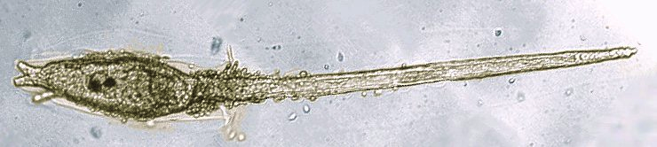

This "tadpole larva" will swim for some time; in many tunicates, it eventually attaches to a hard substrate, it loses its tail and ability to move, and its nervous system largely disintegrates.

.

We should have living specimens that fairly transparent of adults, so you can observe the internal anatomy without dissection.

**Exercise six: Tunicate colonies as Cnidarian and Bryozoan colonies provide refuge for an amazing array of animals. We have found acoel and tubellarian type flatworm, walking clams, skeleton shrimp, snails and several others. Please list any animals you find on the Tunicates. All species shipped will be in one dish, so you may especially in the afternoon lab, have to look around in the dish to find species that have been disturbed and hiding in the debris around the colonies.**

**Exercise seven:** Use the large Cliona for this exercise. Try to introduce a bit of suspended food (very small amounts of phytoplankton or micro vert food) and see if you can observe where water is entering and exiting, identifying in the process the incurrent and excurrent siphons. You will have to focus on high power to see the small particles enter. **Film this activity if you are lucky enough to observe it. You should at least be able to film the opening and closing of the larger branchial siphon. If you are lucky a specimen may in the process of ejecting undigested material open its atrial siphon.**

**Exercise eight: Identify as many of the structures on the diagram below as you can.** Different features will be apparent from different angles as you will have to use higher power with an animal that is fairly thick and so you will lose depth of field quickly**. A photograph of the digestive system or branchial basket will suffice for internal anatomy. You should also photograph if you could not film feeding, the two siphons. Can you determine which is the Branchial or inflow siphon? It is usually the larger one and the Atrial or outflow siphon is not only smaller, but sometimes found to the side of the branchial siphon.**

**Adult anatomy:**

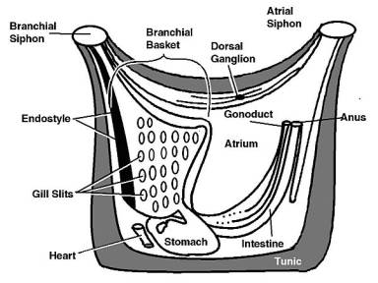

Students previously were able to resolve beating hearts, watch reversal of flow, etc. We have located three specimens in which you can witness the fluid moving within the animals. **You may also try to locate the heart region in some of the more transparent larger specimens of Cliona.** Be patient and look for movement on the bottom and to the side (narrow angle) of the animal. It may help if your partner gently with gloved hand turns the animal so the narrow side next to the branchial basket is facing you**.**

**Exercise nine: You should attempt to film flow (essentially heart beat) in general across the branchial basket. Please share your films and observations with the class if you are fortunate enough to be able to obtain a cooperative specimen.**

A more detailed description of anatomy follows, to help you with notes for your journal.

The underlying epidermis secretes the outer body wall, the tunic, and preserved specimens may have a considerable amount of dirt and debris caught in its surface. The tunic is given this unique name because it isn’t a non-living cuticle. The tunic may contain wandering amoebocytes and extensions of the underlying epidermis.

There are two large openings in the tunic and each represents one end of the U-shaped body. The anterior branchial siphon carries water into the animal and the dorsal atrial siphon carries it out. The visceral mass at the bottom of the tunic is the posterior side of the animal. The branchial siphon has a ring of tentacles that surround the mouth and they prevent large objects from entering and are chemosensory as well. If you look closely at the body wall of both siphons you’ll see the musculature that opens, closes and changes the diameter of the siphon opening. Longitudinal muscles are also involved in the closing and opening of the siphons.

Below the incurrent siphon is the large branchial basket. Food laden water is pulled into the basket and trapped in a sheet of mucus produced by the endostyle, which appears as a dark groove running the length of the basket. Water that enters the basket, passes through the mucus bag and the openings in the wall of the basket to the atrium and the excurrent siphon. Carefully focus on the basket and you’ll see the openings in the wall, the stigmata. They are lined with cilia and create the water current.

The sheet of mucous produced by the endostyle spreads across the inner surface of the basket until it reaches the dorsal lamina on the opposite side. Here the mucous bag is rolled up and cilia pass it down and into the esophagus. The digestive tract is S-shaped and the stomach is found at the posterior end of the tunicate and the intestine winds its way up and towards the atrial siphon. You may be able to see the digestive gland on the surface and if you do it’s a convenient way to tell the difference between the stomach and the start of the intestine.

The other prominent internal organs are the single ovary and testes, located in the fold of the stomach and intestine. The testes wrap around the ovary and the genital duct leads to a sperm duct, also located in the atrial siphon.

The heart lies inside a muscular pericardial cavity below the stomach and two blood vessels supply the viscera, the visceral vessel, or the branchial basket, the branchial vessel. The tunicate heart is unusual in how it beats, sometimes pumping blood in one direction, and then reversing the beat to pump it in the other. Depending which type of beat is occurring and when, these vessels alternate between being arteries and veins!